Lilly Technical Challenge Documentation

Approach
- Identification of requirements
After observing the API and how the data structure looks like using postman to test and view responses where I figured there are medicine without name, price and null.
- Scope Implementation
I further systematically decide on the levels it is required to pass before presentation on the UI, which are request, response, display actions.
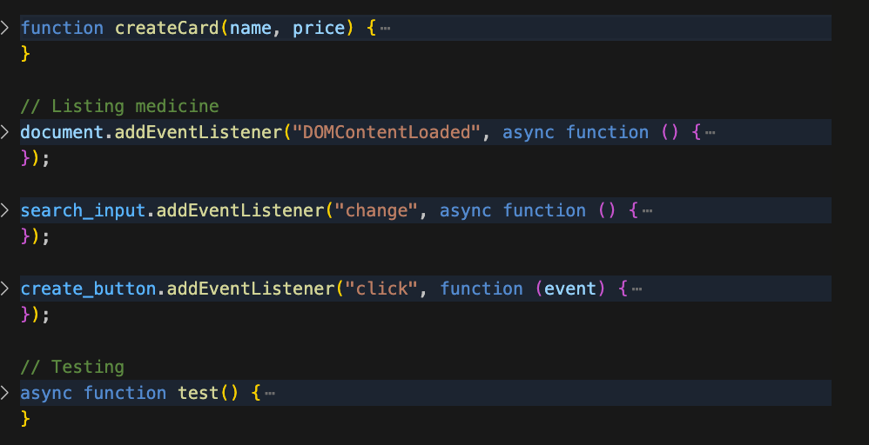
- Error Handling
I utilised try catch blocks to ensure that that API response and errors are caught with reasonable messages which will be displayed to the users.
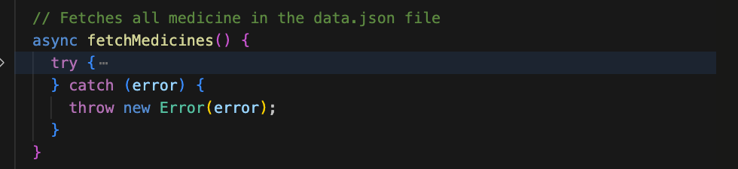
- OOP concept
For maintainable and reuseable code I implemented the OOP concepts by splitting the codes and using specifically Inheritance to access request and actions.
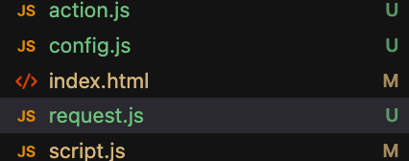
- Components
My UI was design with the thinking of reusability using w3school as a reference for concept like template.

Objective
- Invalid data handling/Missing Data
Managed missing data by passing a check to see if the name or price of the medicine is either empty or null, otherwise it has been replaced with texts “No Price, Unknown”.
- User friendly Interface
I utilised the user of grid to construct a specific layout for the website before designing components which are reuseable across the application.

Problem Faced
- Deleting Missing Data
Data without name or price was a bit tricky to delete at first but with strict initialization based on item keys it was possible.
- Conversion
Faced issues with converting integers/numbers to float which was not fix due to time.
- Items Properties
Medicines are individually assigning actions with their own properties; to maintain the maintainability of the code I had to implement templates which helped with making actions unique.
- UI
In the process of designing I encountered issues with passing actions to buttons. I first passed the code into JS using pure html but it was looking for a bit off, then had to go back and reconsider using templates which is been clone with unique characters for each Medicine Items.
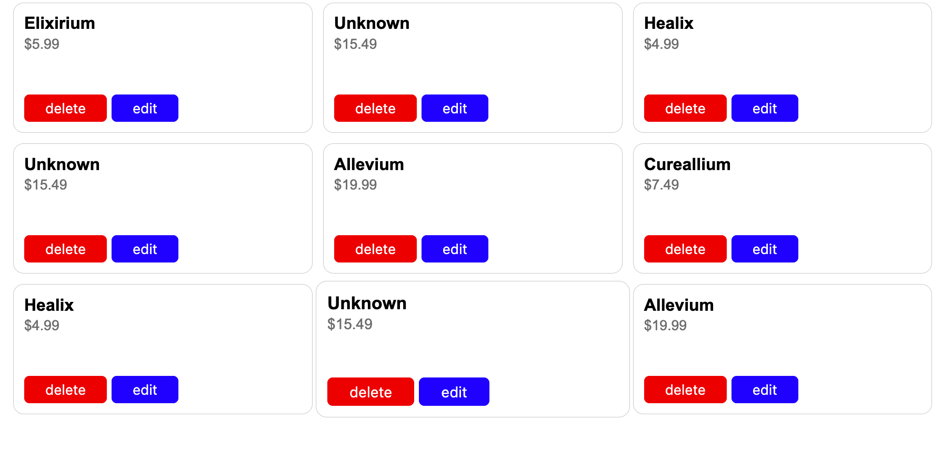

Evaluation
The challenge consists of different areas of focus to ensure that the frontend can handle data from the backend adequately.
I will further implement initial state to show case message should in case there are network issues if there was more time.
Interactivity will be better, with implementation of loading animations to show functionality or processing state of the website if there was more time.
Implementing the backend wasn’t totally complex however managed to implement a few functions within time.
With more time I will be able to implement a lot more following that the backend accepts duplicates, I will be able sort out existing medicines and much more.

